An Entity System for

Unity: 2015-1

Who am I?

• Former game developer + CTO

• Building Entity Systems since 2002

• Writing about Entity Systems since 2007

• Now teaching children to program (Ages

6-16), and training teachers

I

Editor Customization

❤

❤

I

Editor Customization

*[bitch on Twitter about]*

Unity Editor is still a

**Black Art**

WARNING!

WARNING!

“Here Be Generalizations”

WARNING!

“Here Be Generalizations”

(only a short talk, lots to cover)

Today ...

... Entity Systems

Why use an Entity

System?

• 1. Quicker prototyping (games, features)

• 2. Faster game (CPU, RAM, Mobile)

• 3. Easier code (debug less, design more)

What is an Entity

System?



What is an Entity

System?

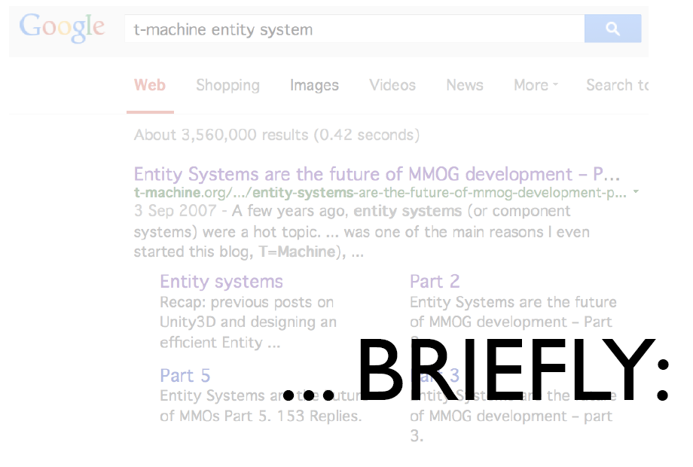

IT Industry attempts

Computer Games

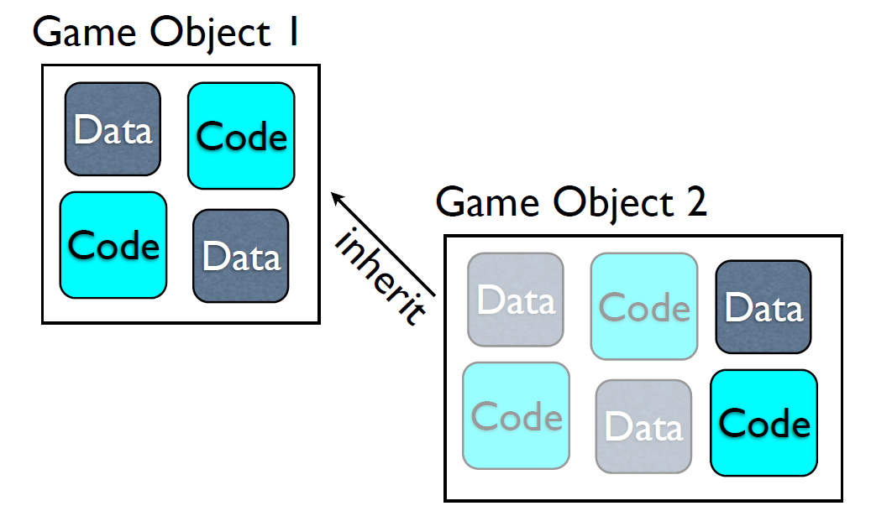

IT Industry attempts

Computer Games

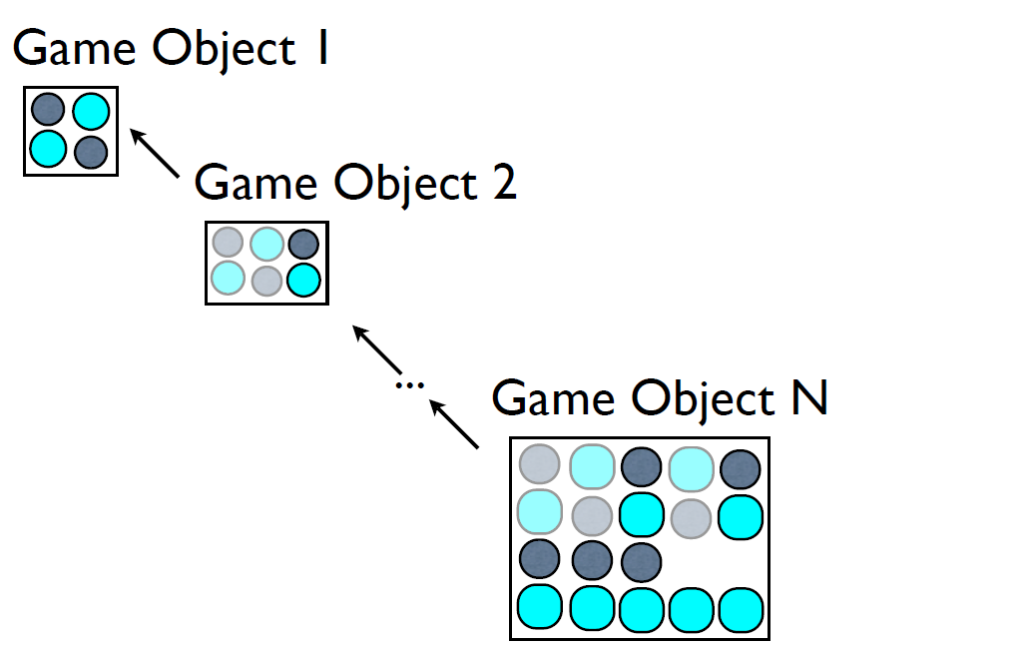

IT Industry attempts

Computer Games

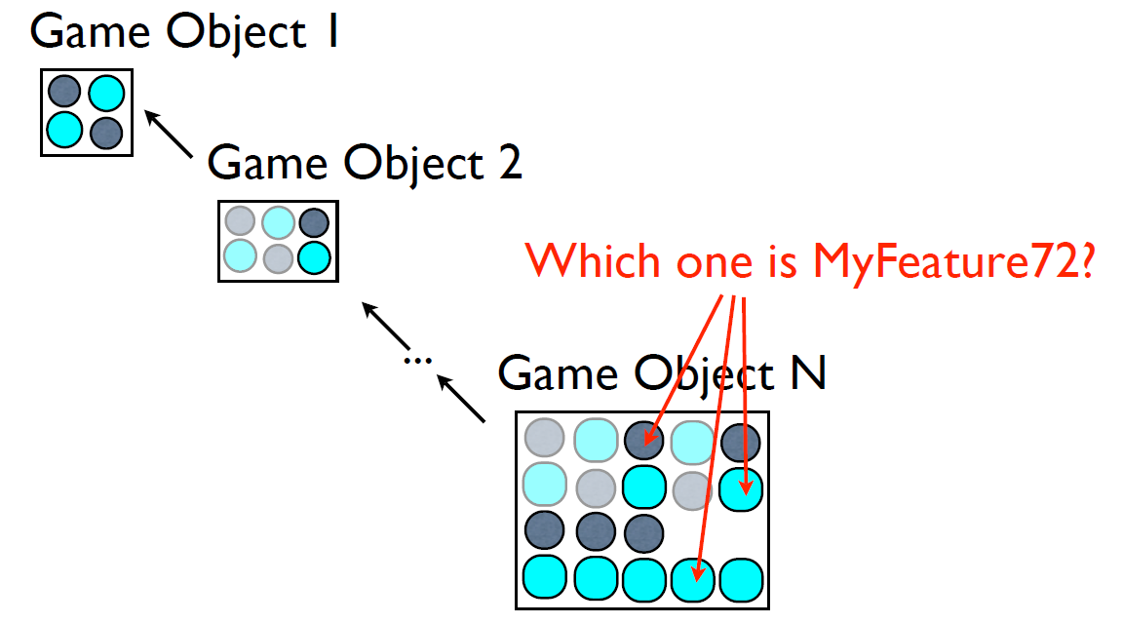

Computer hates it too

• Modern computers terribly slow at doing

“one RANDOM little piece at a time”

• Memory-fragmentation is an Unsolved

Problem (tm)

• Multithreaded code / processors detest

OOP encapsulation

Unity does Computer

Games

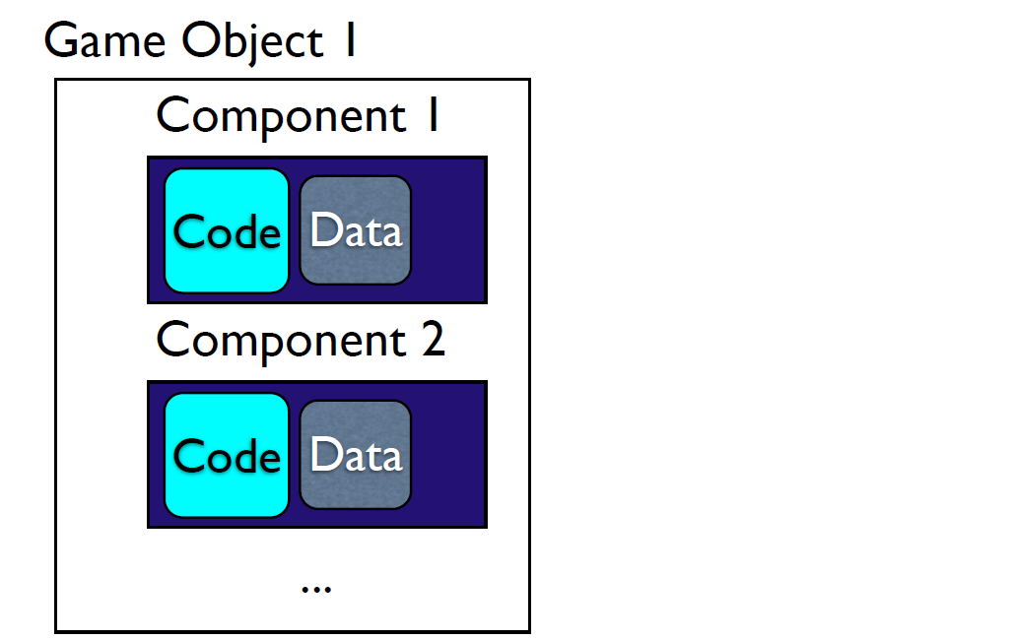

Unity does Computer

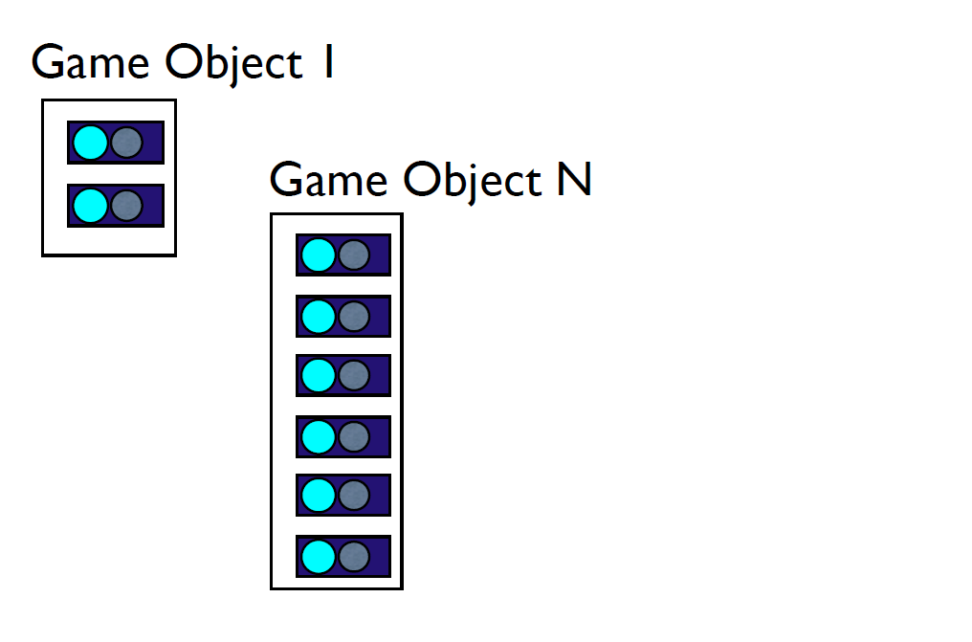

Unity does Computer

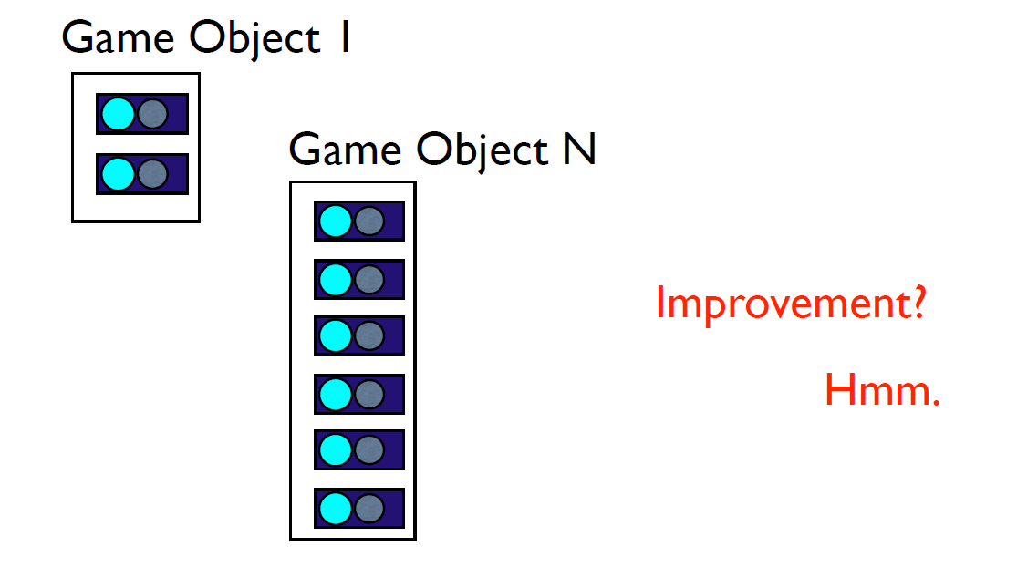

GameDevs make

EntitySystems

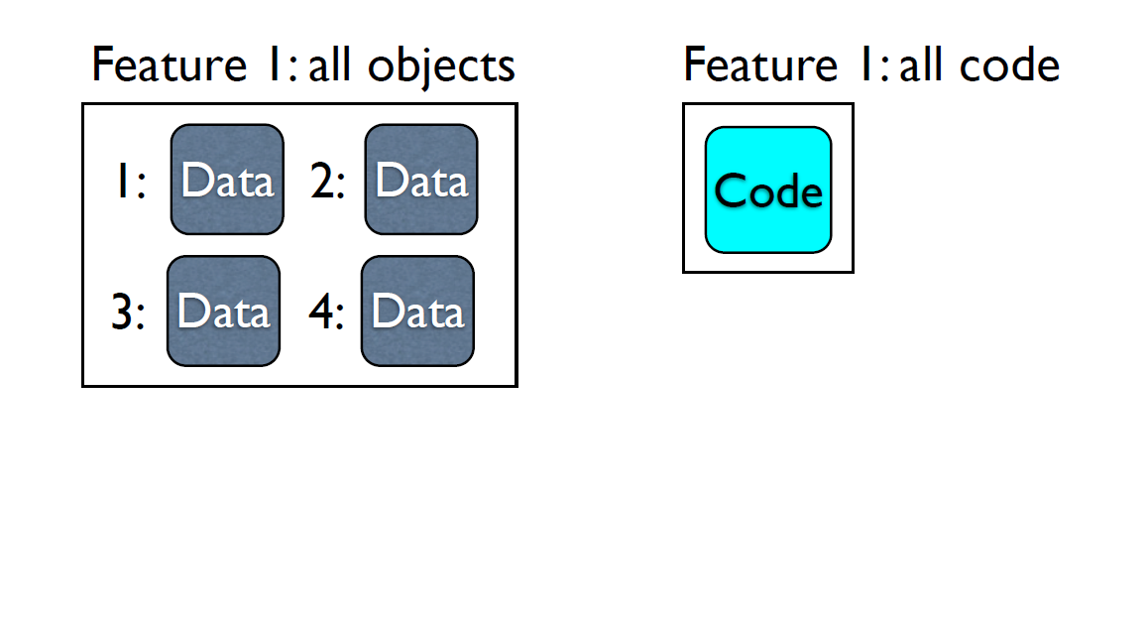

GameDevs make

EntitySystems

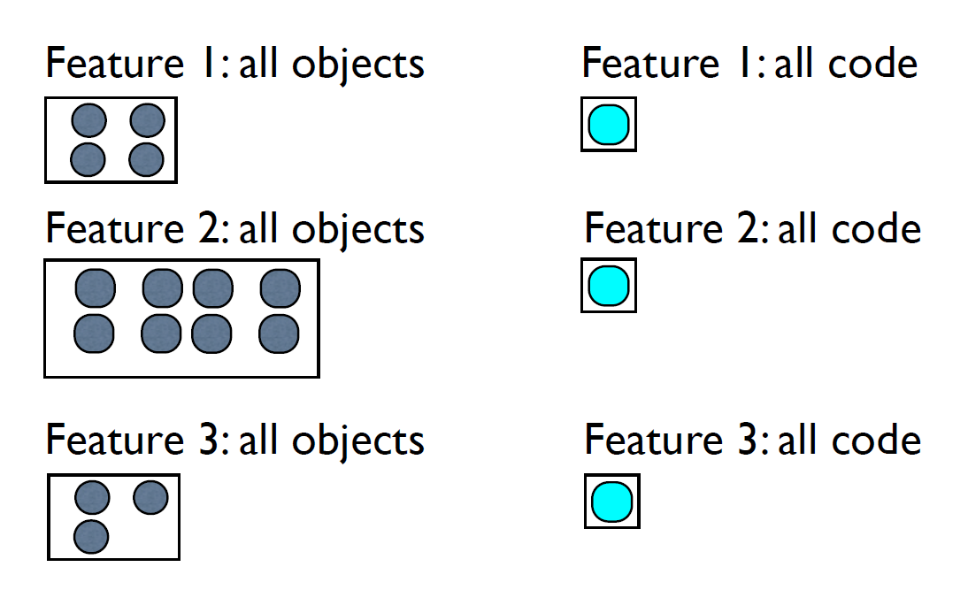

GameDevs make

EntitySystems

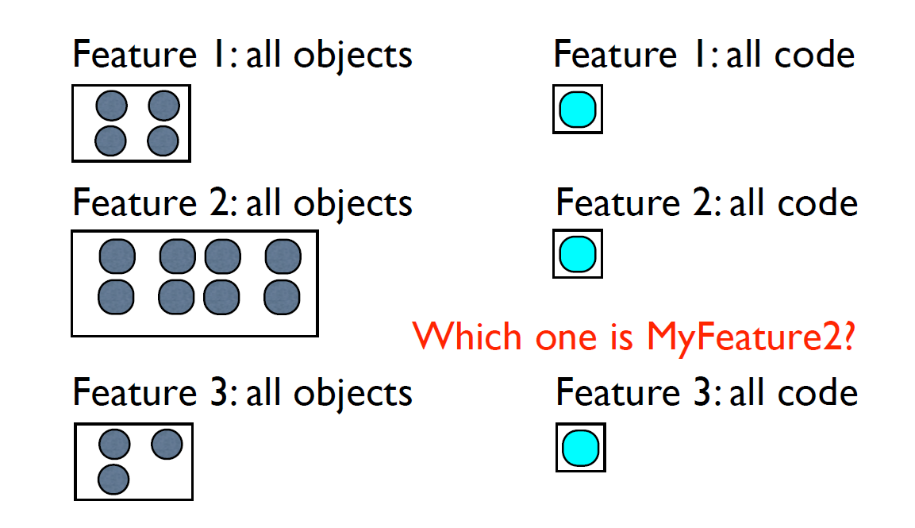

GameDevs make

EntitySystems

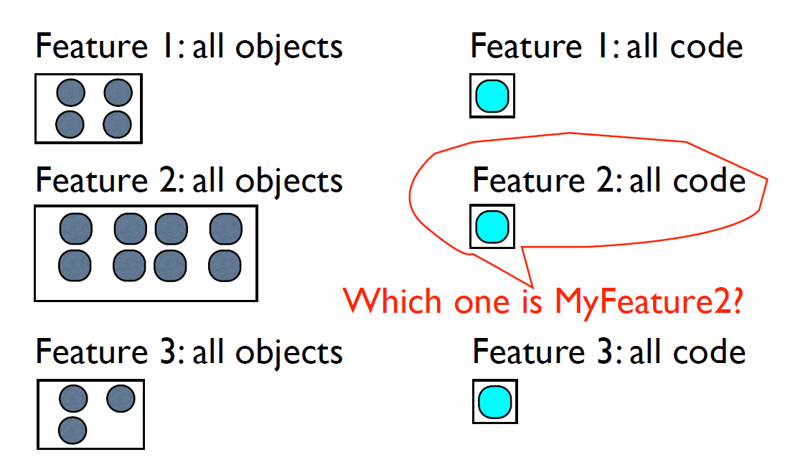

Computer loves it too

• Can do “all the Feature N” objects at once

• Fragmentation much easier to cope with

• Multithreading is EASY! (almost: Free)

In practice, though...

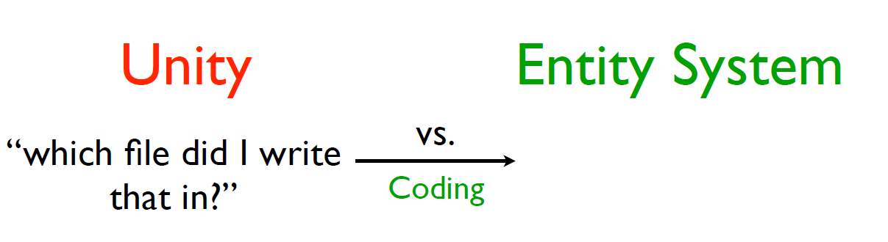

In practice, though...

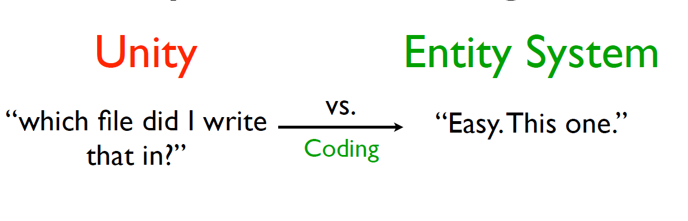

In practice, though...

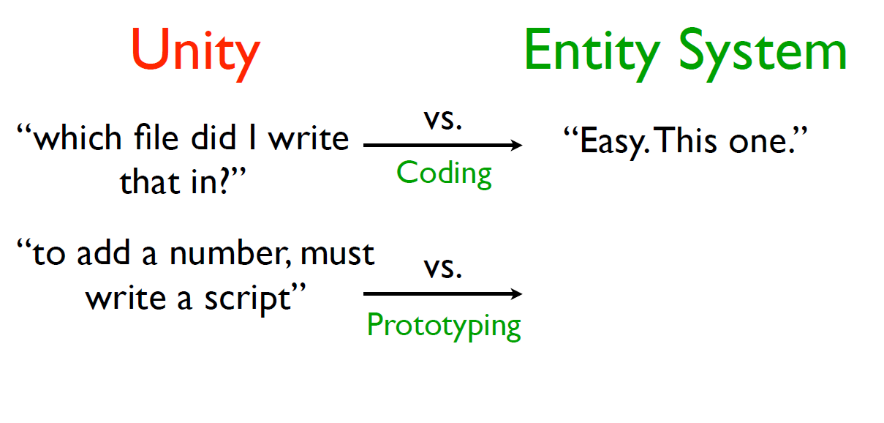

In practice, though...

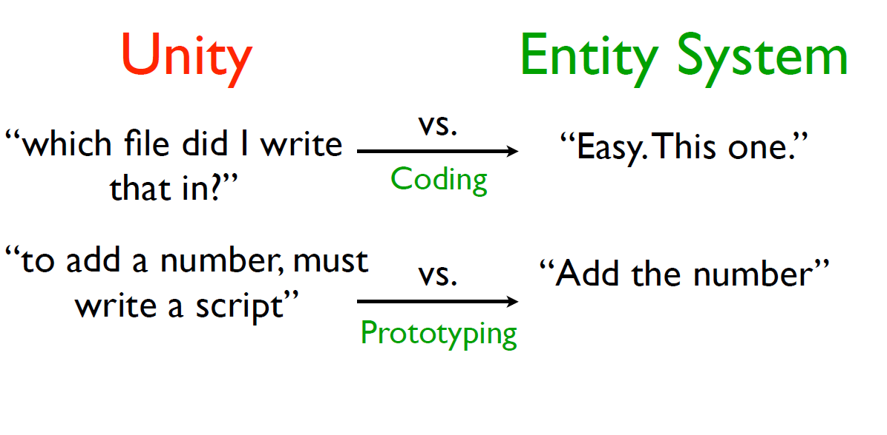

In practice, though...

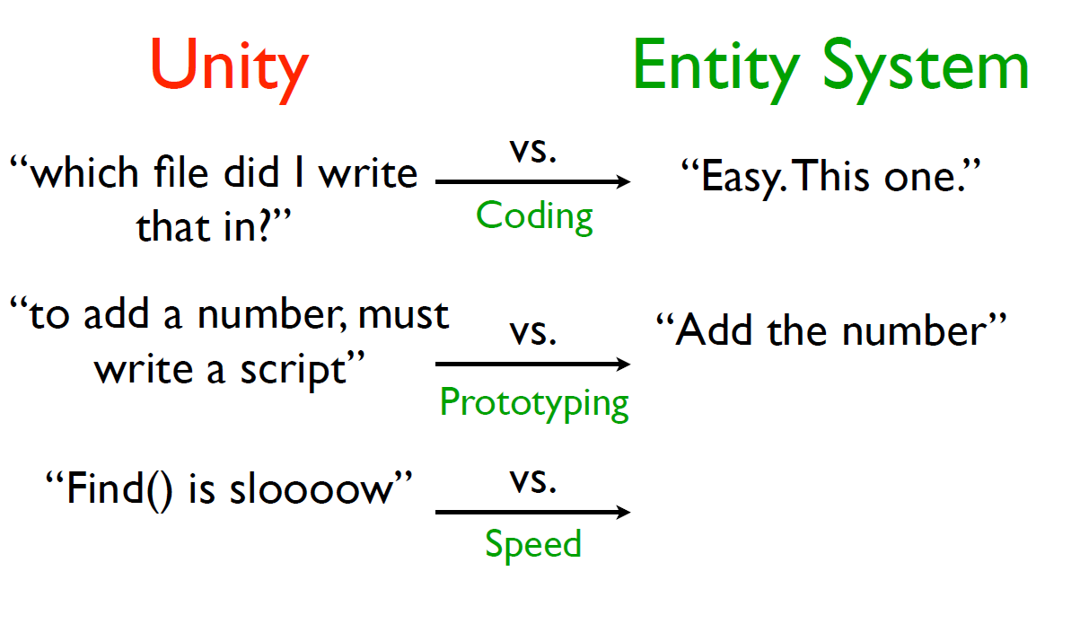

In practice, though...

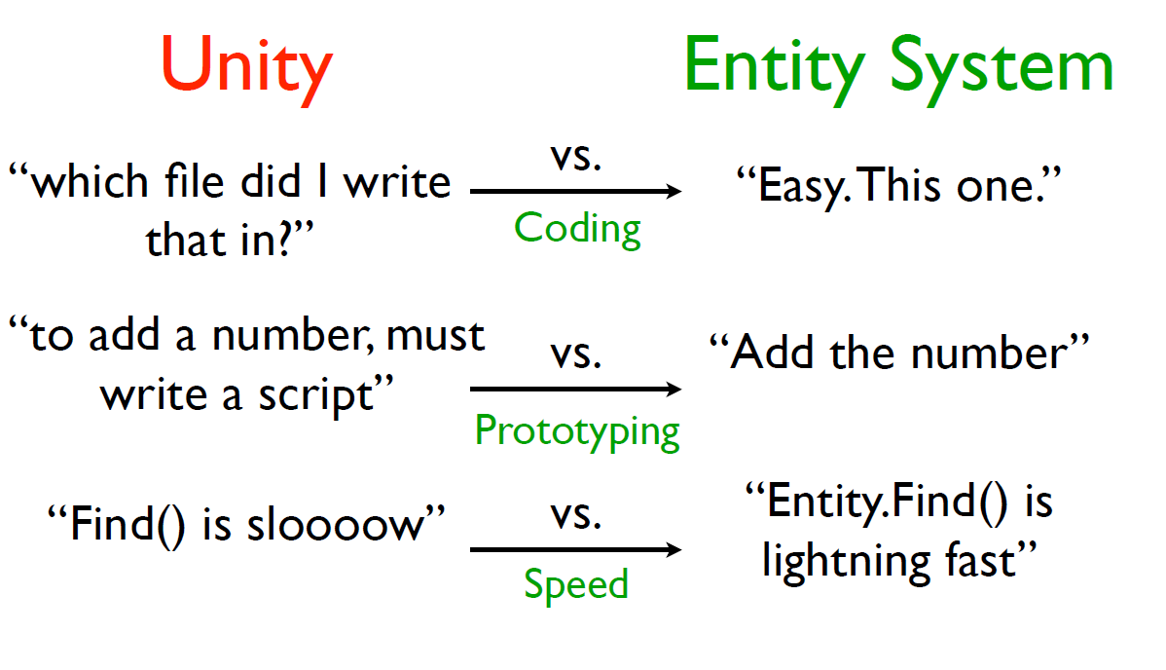

Generally speaking

• Every “new game feature” is quicker to try

• Every algorithm requires less source code

• Bugs are easier to isolate

• Performance is improved across the board

Entity Systems

... inside Unity

3 x Key Areas

• Making stuff in the Editor

• Writing + editing scripts

• Running in the Player (Runtime)

(recap)

Why use an Entity

System?

• 1. Quicker prototyping (games, features)

• 2. Faster game (CPU, RAM, Mobile)

• 3. Easier code (debug less, design more)

(a.k.a.)

Why use an Entity

System?

• 1. Easier to add game-features

• 2. Runs faster

• 3. Less / easier Debugging

Effectiveness

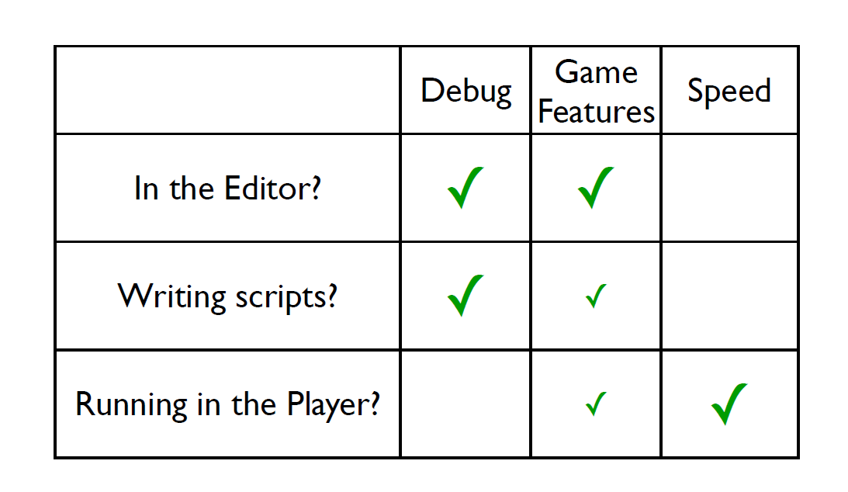

Editor, I choose you!

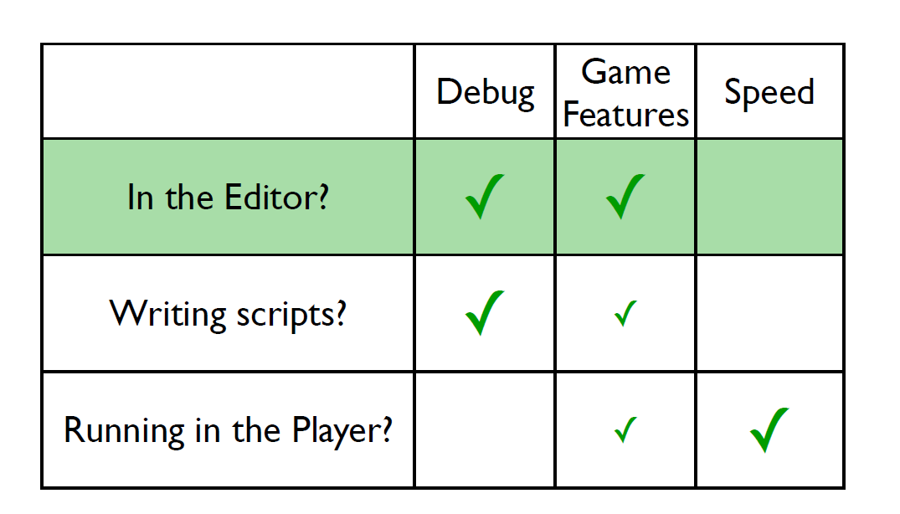

In-Editor Goals

• Is it easy to use?

• ... easier than plain Unity?

• Can this be implemented in C#?

• ... without destroying performance?

• ... without writing “bad code”?

• ... without “bizarre coding practices”?

Challenges so far...

3 problems

• 1. Unity Serialization

• 2. Unity Serialization

• 3. Unity Serialization

3 problems

• 1. Unity Serialization

• 2. Unity Serialization

• 3. Unity Serialization

3 problems

• 1. Unity Serialization

• 2. Unity Serialization

• 3. Unity Serialization

“I



Unity ... “challenges”

• Unity has no API for save/load to a Scene

• ScriptableObject is half-implemented, halfbroken

• ...Unity Serialization

Unity Serialization ...

“challenges”

• ..requires SetDirty

• ..sometimes ignores SetDirty

• SetDirty needs Find

• Unity doesn’t fully support Find (yet)

• ..doesn’t support C# core classes

• ..restoring breaks “static” variables

• ..“change scene” code in Unity 5 is wrong

• ..C# Constructors go FUBAR

• ..THERE’S NO DEBUG INFORMATION

• ..zero Editor support from Unity Corp

Unity Serialization ...

“challenges”



...and C#

• “return ref” isn’t possible (C#)

Progress so far...

... in Editor



Project Window

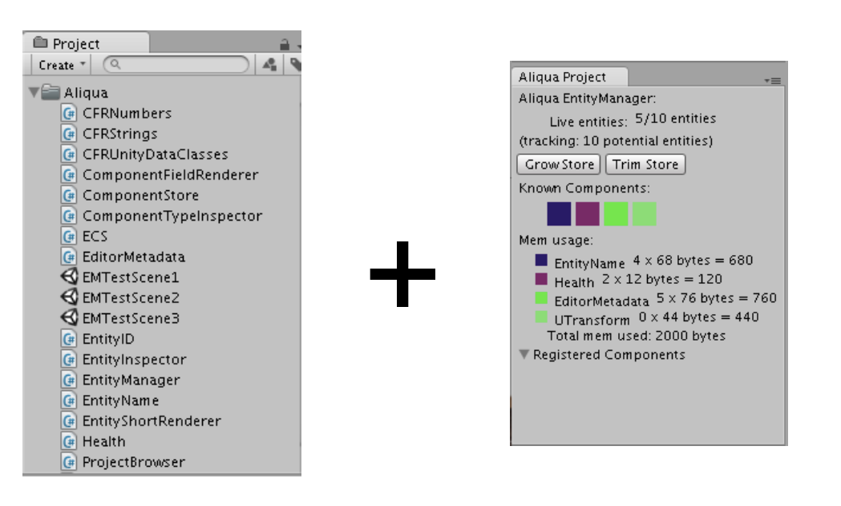

Project Window

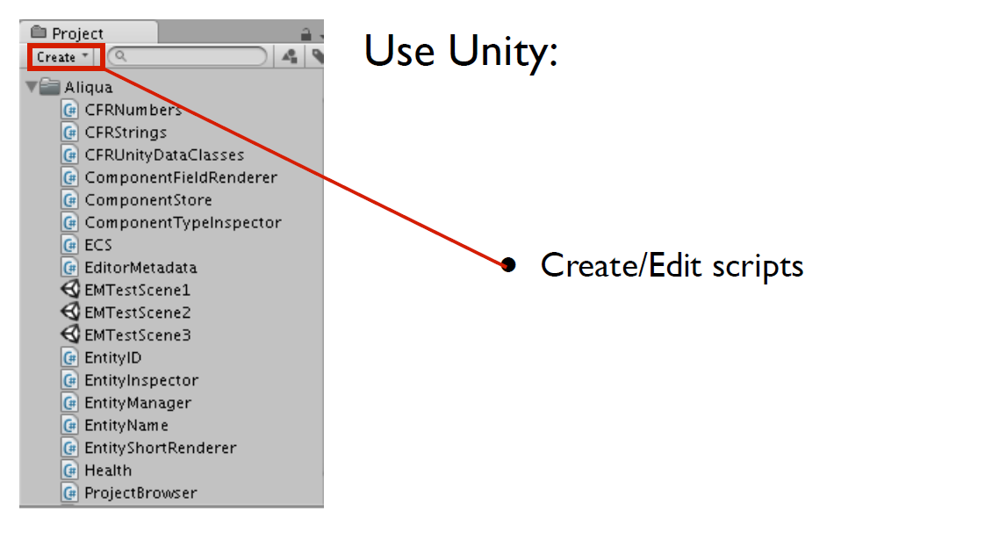

Project Window

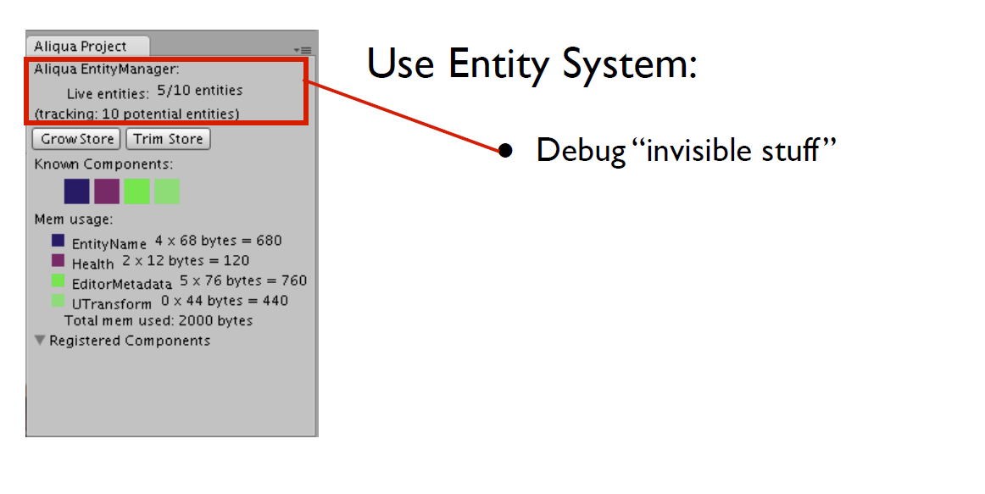

Project Window

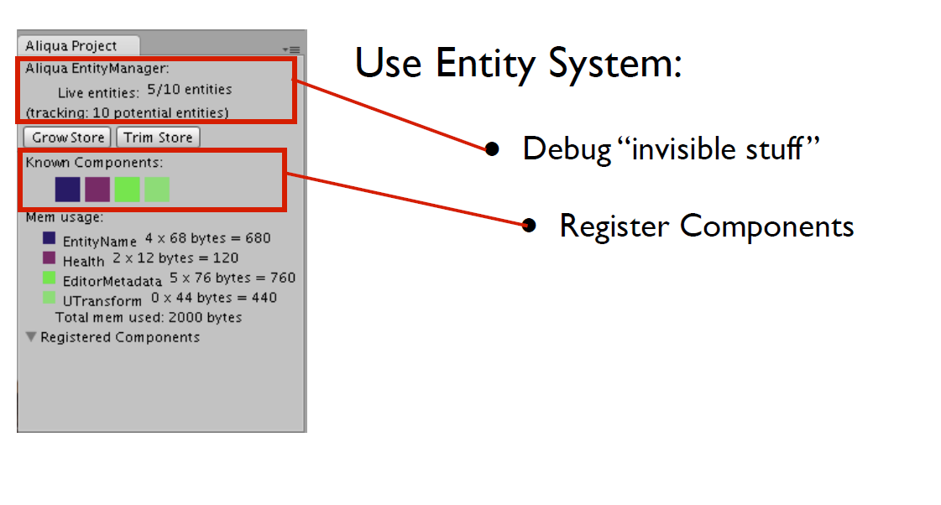

Project Window

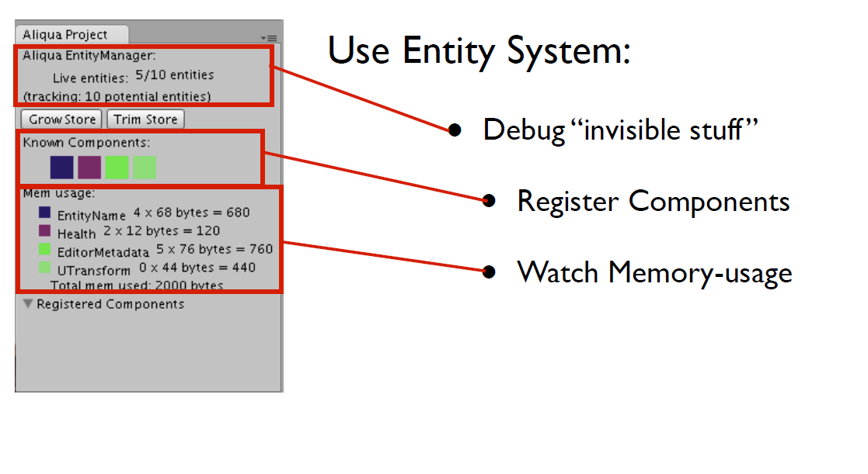

Project Window

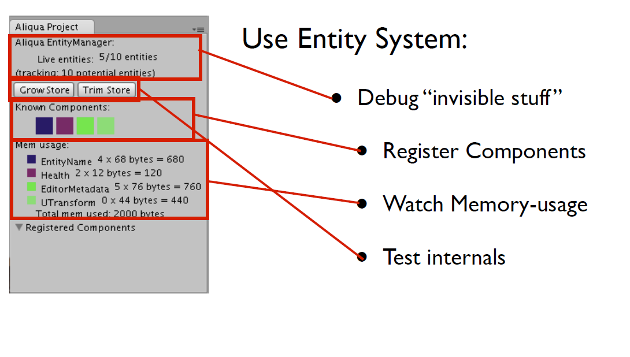

Project Window

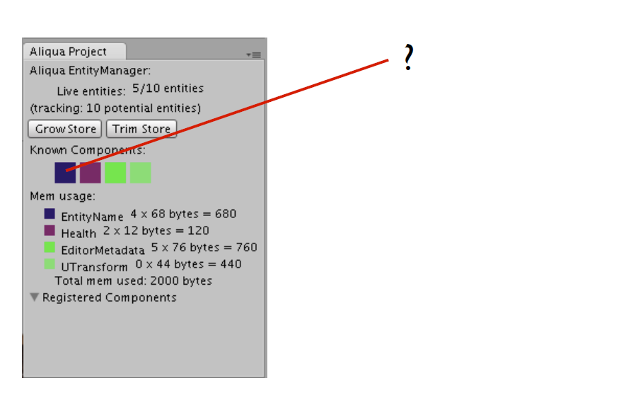

Project Window

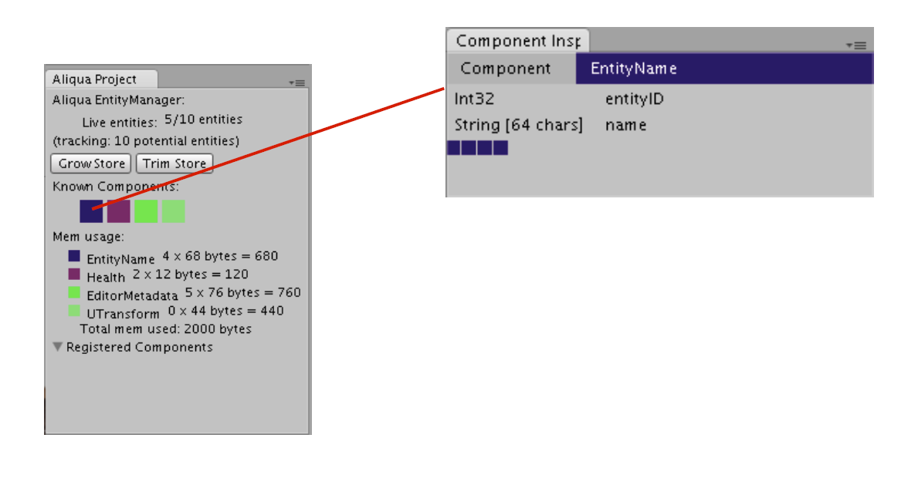

Project Window

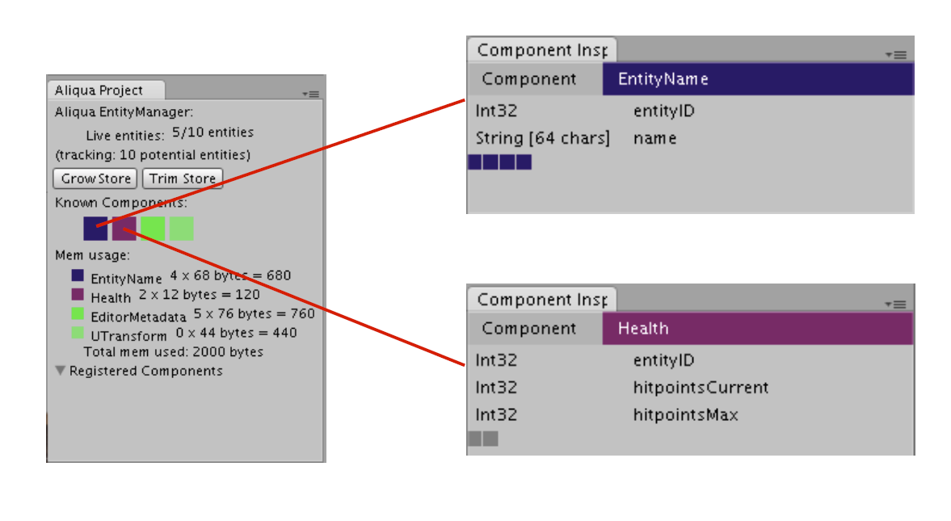

Project Window

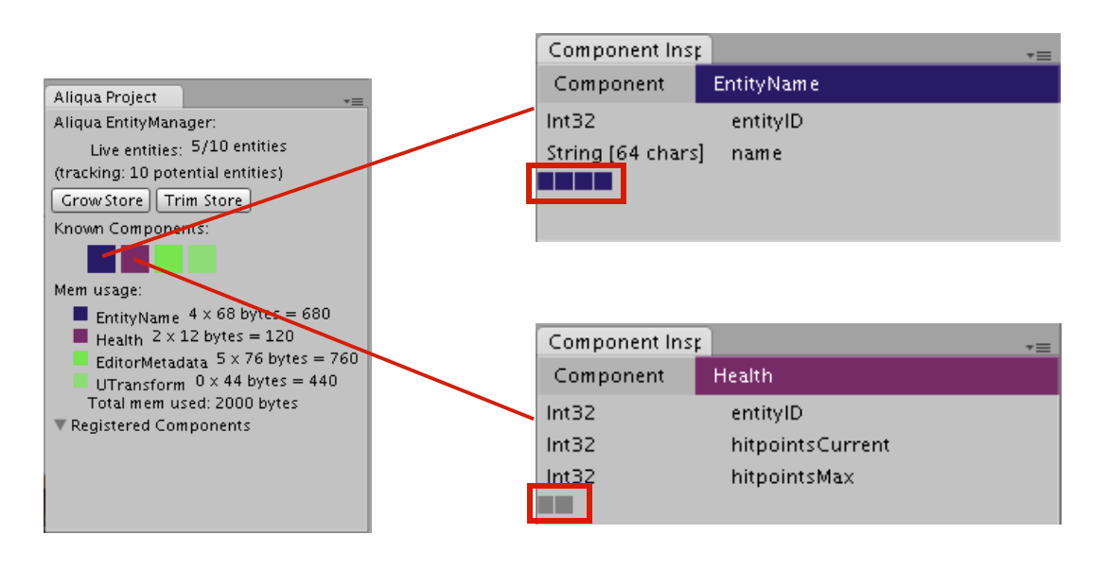

Project Window

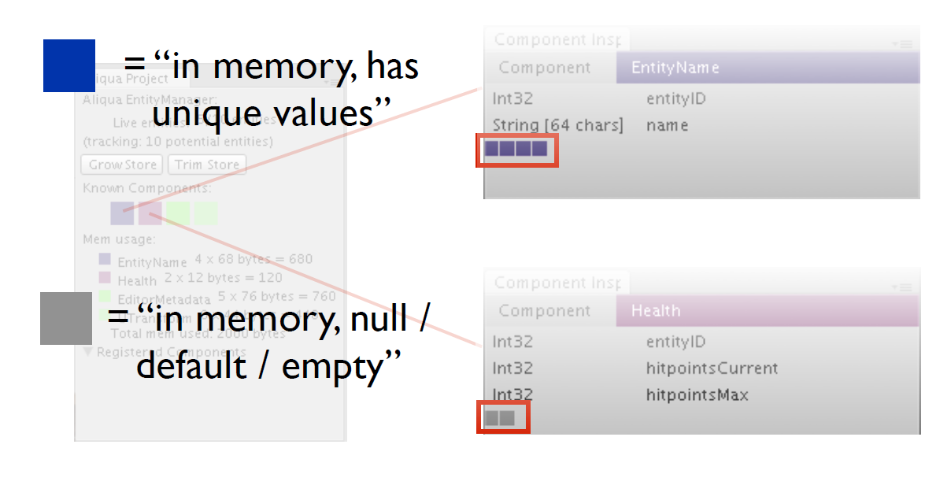

Project Window



Project Window

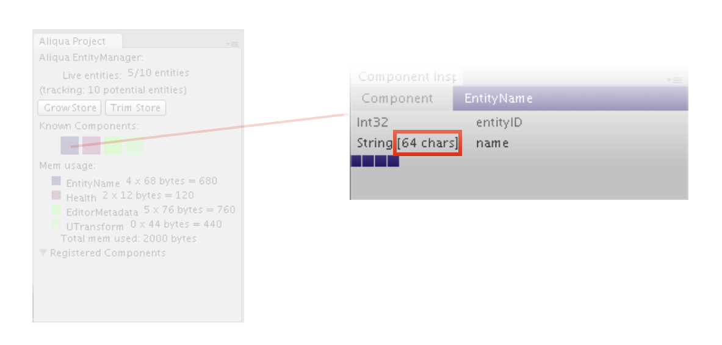

Project Window

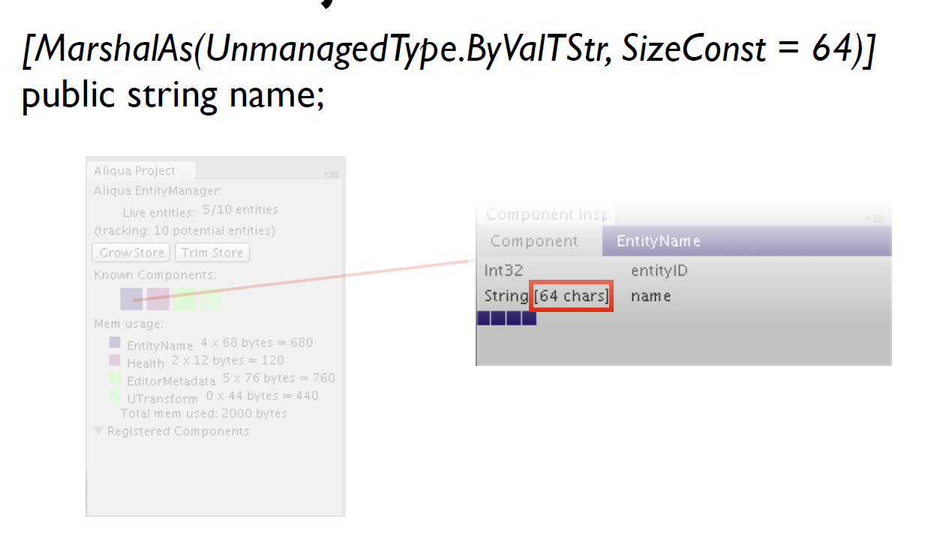

Project Window

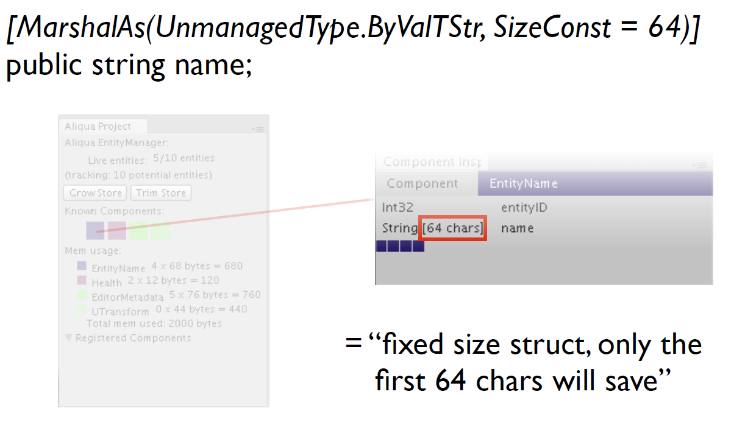

Hierarchy Window



Hierarchy Window



Hierarchy Window

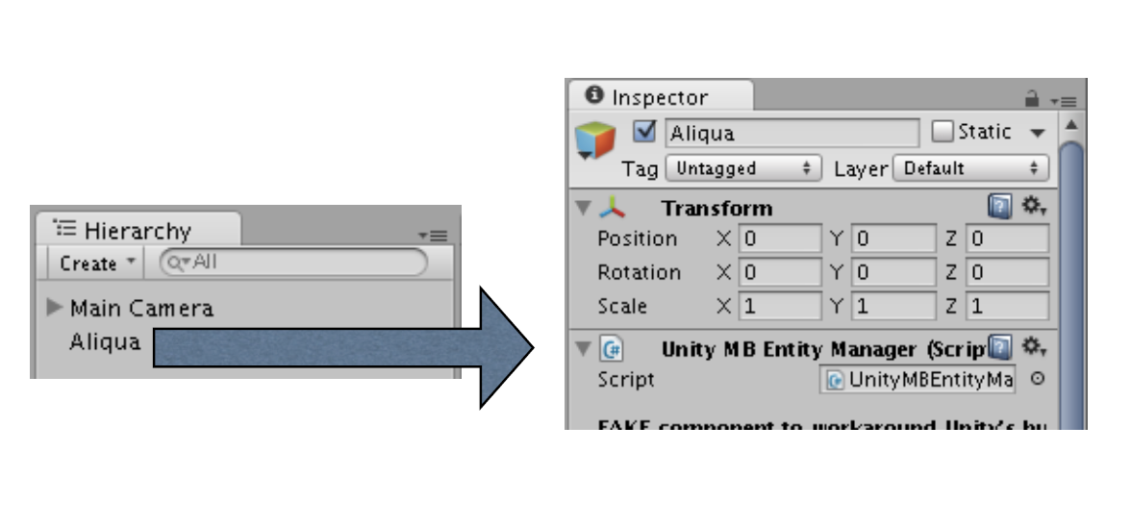

Hierarchy Window

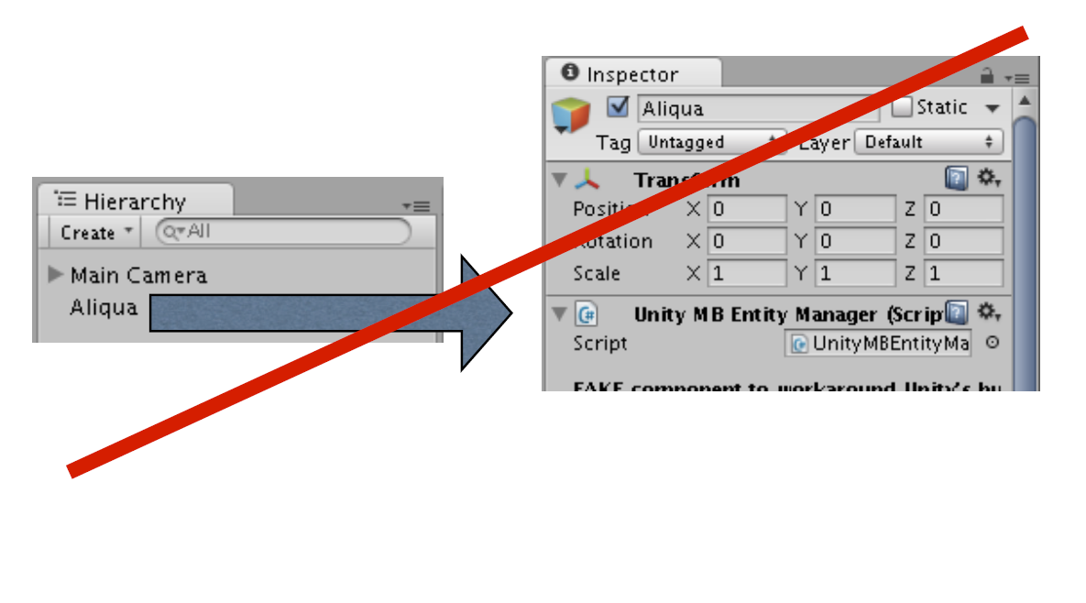

Hierarchy Window

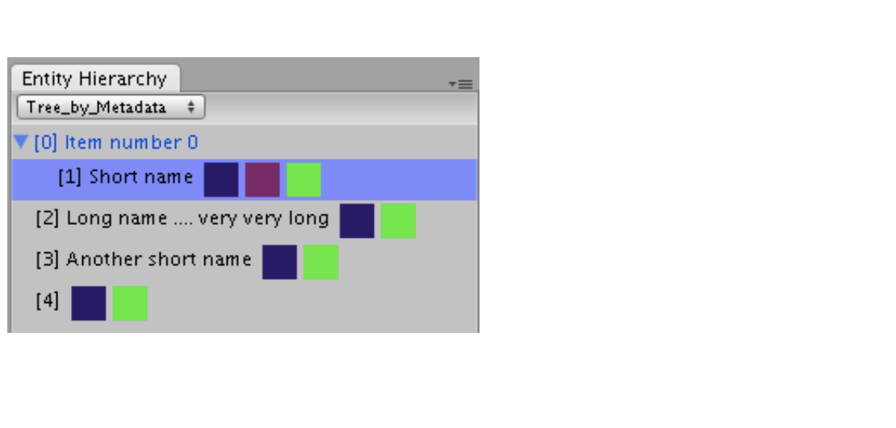

Hierarchy Window

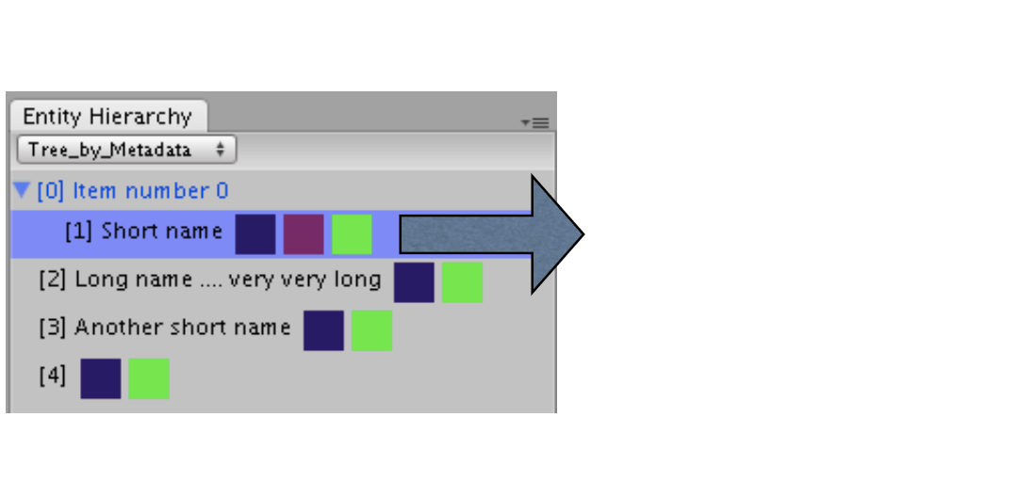

Hierarchy Window

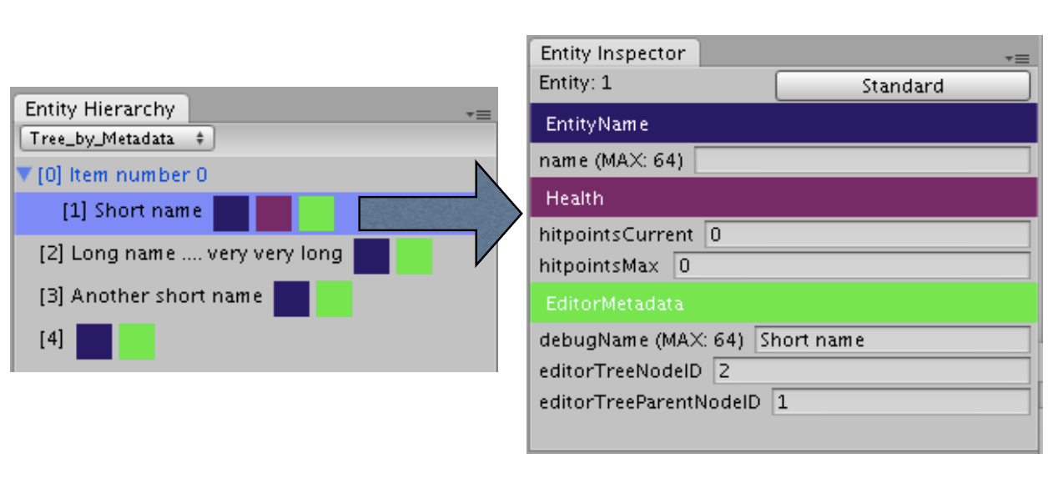

Hierarchy Window

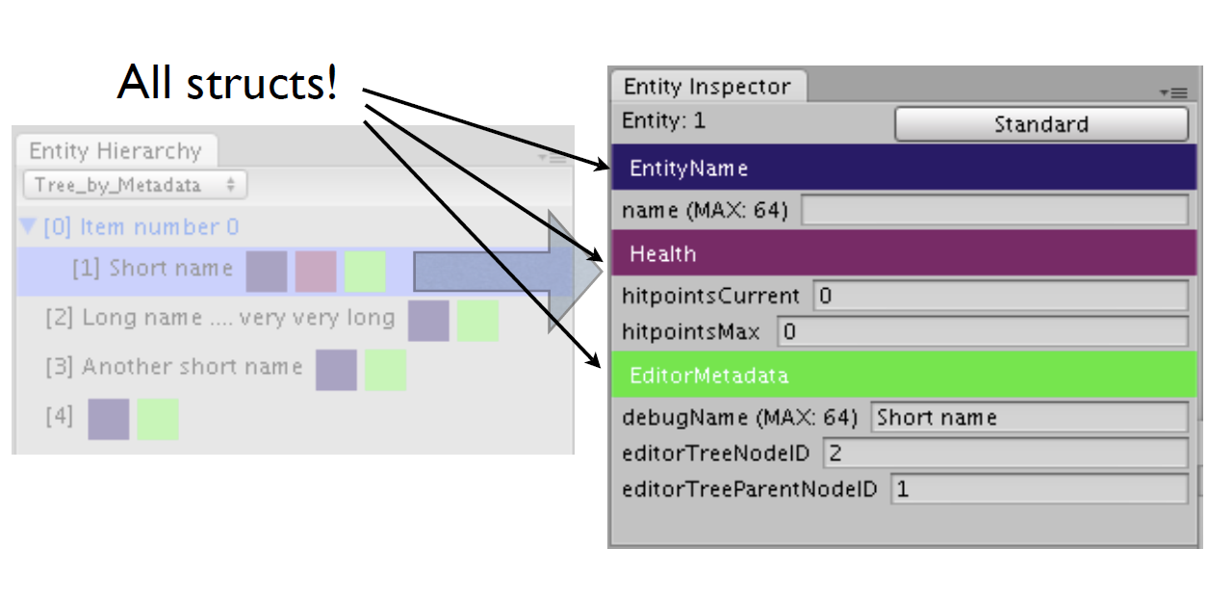

Hierarchy Window

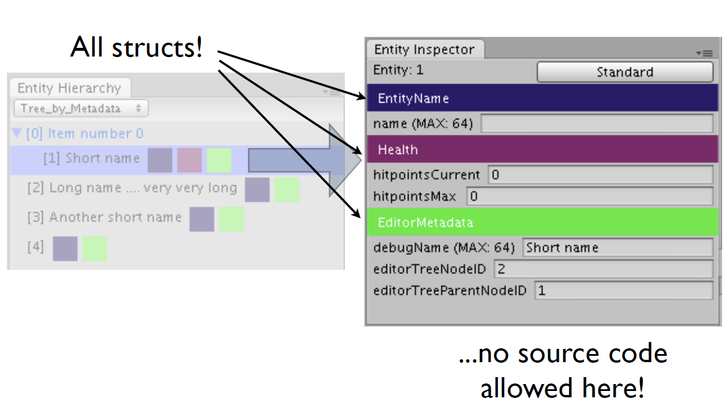

Hierarchy Window

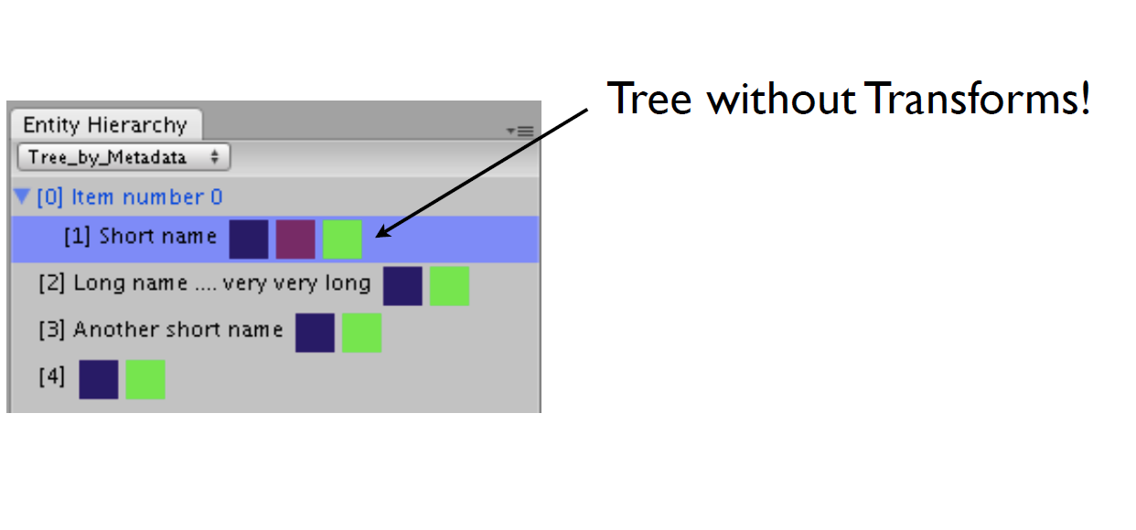

Hierarchy Window

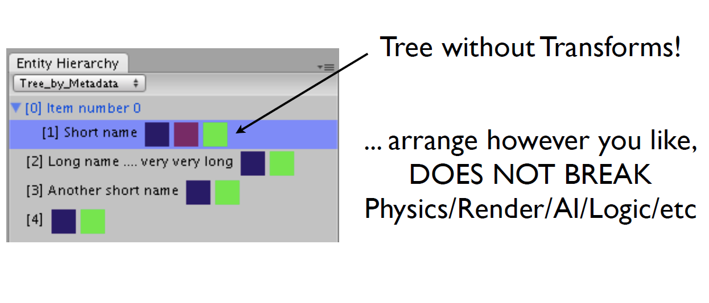

Hierarchy Window

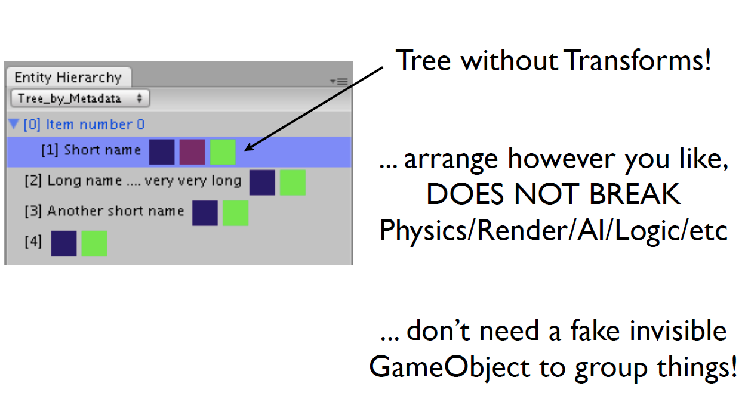

Hierarchy Window

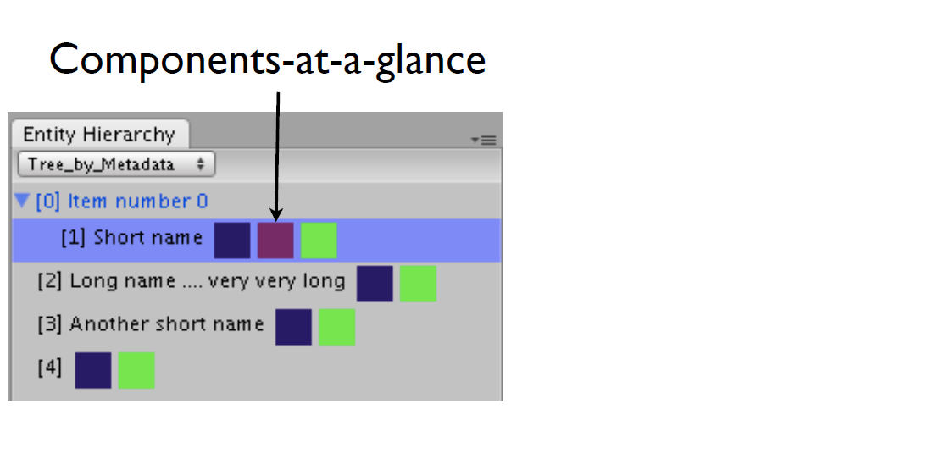

Hierarchy Window

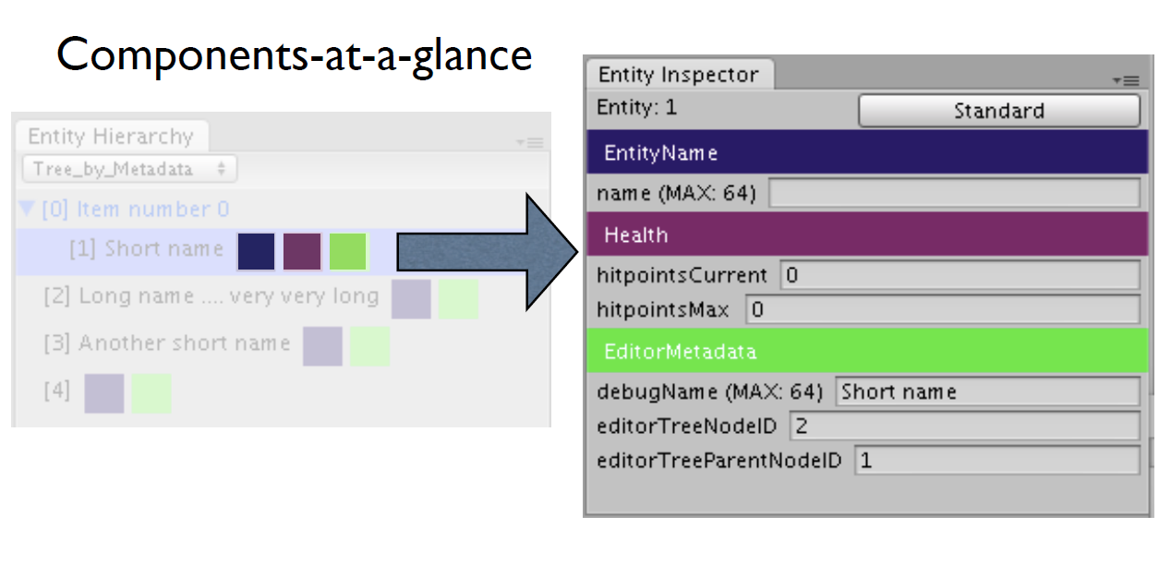

Hierarchy Window

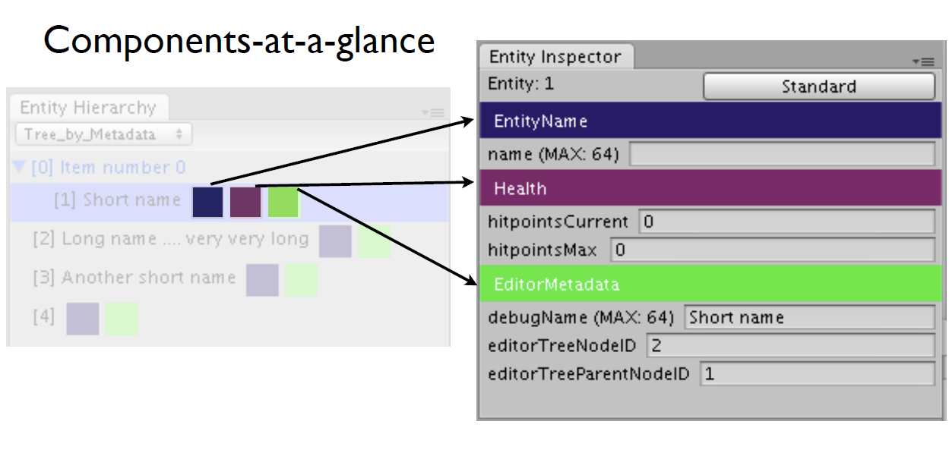

Hierarchy Window

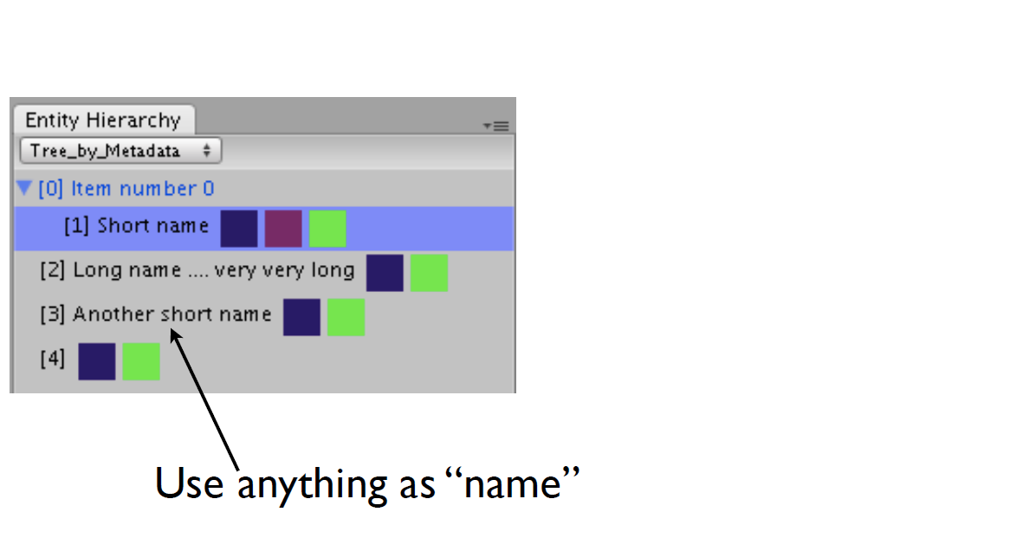

Hierarchy Window

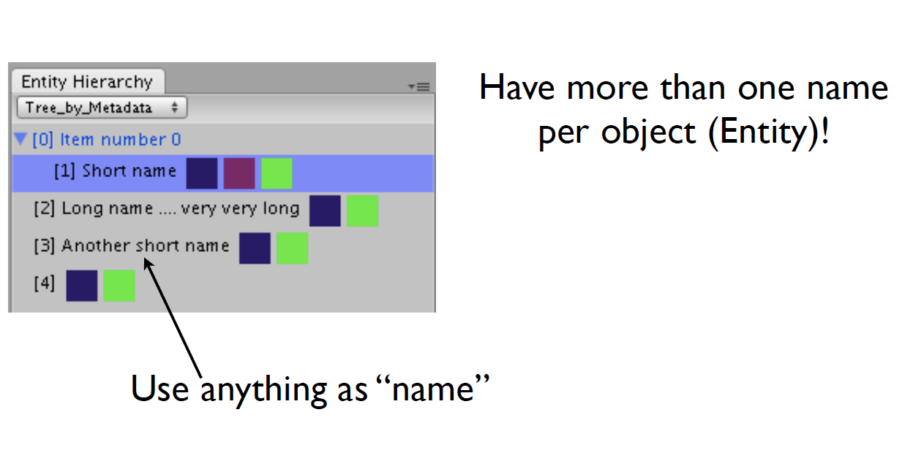

Hierarchy Window

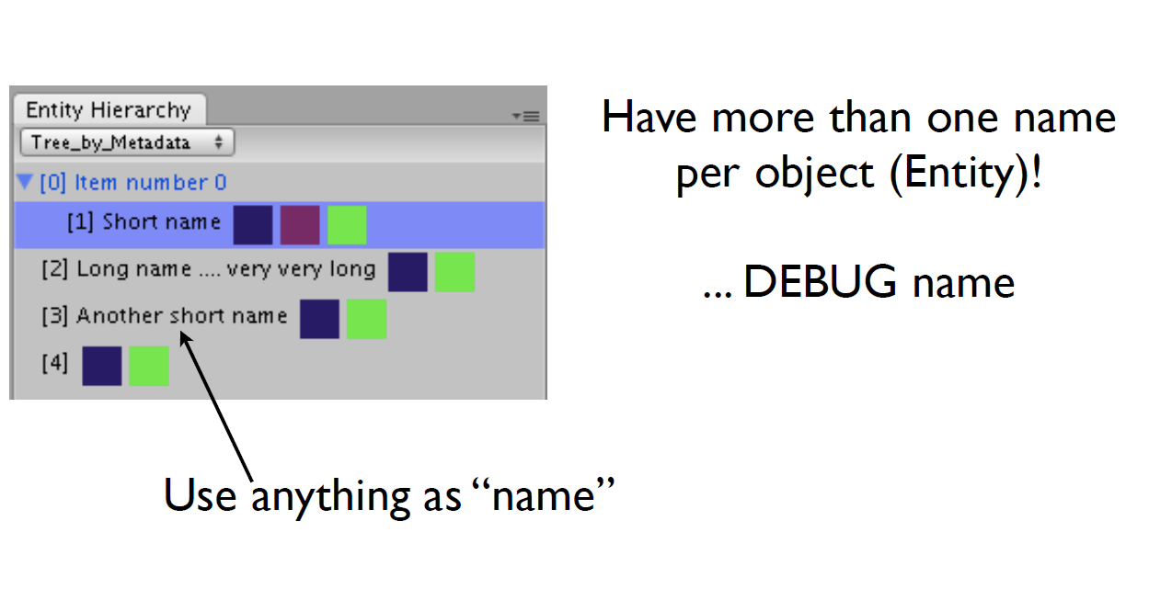

Hierarchy Window

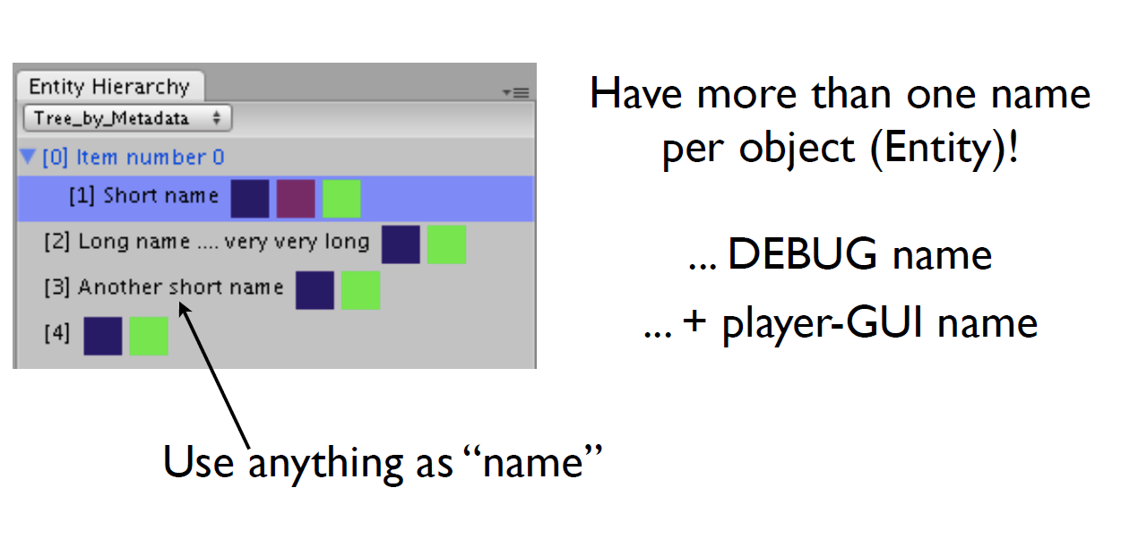

Hierarchy Window

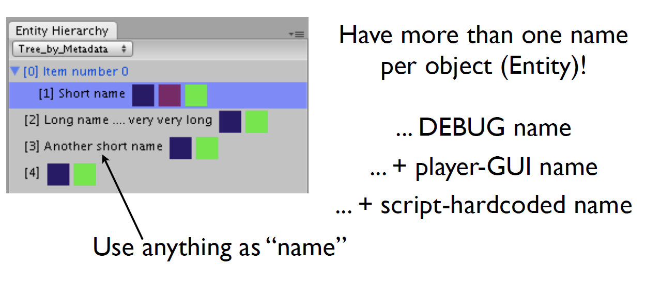

Hierarchy Window

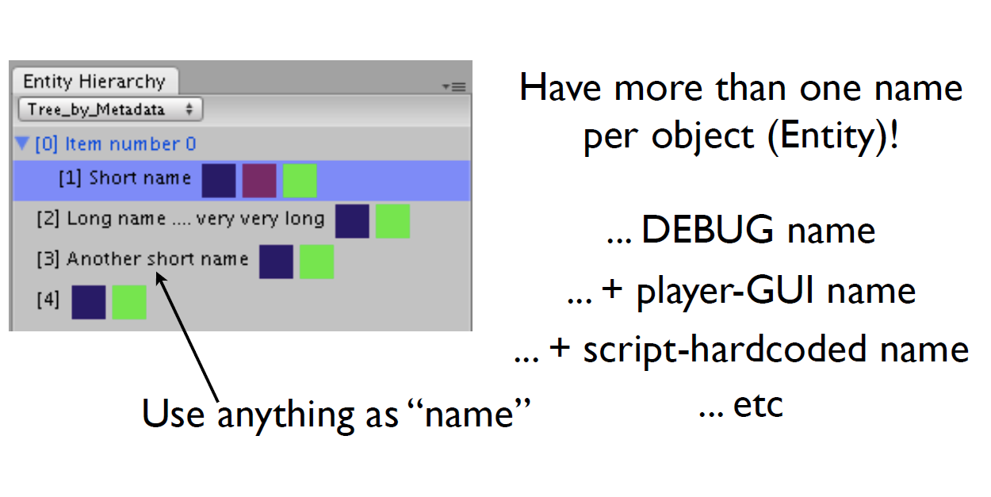

Progress so far...

... in Source Code

Source Code

• All Components are C# struct

• structs stored in massive raw [arrays]

• Generics guarantee safe + fast access

• Components can be fast-copied by C#

• Everything saved to Unity Serialization

Problem:

no “return ref”

struct Position;

private Position[1000] allPositions;

public *Position GetPosition( ID identifier );

Problem:

no “return ref”

struct Position;

private Position[1000] allPositions;

public *Position GetPosition( ID identifier );

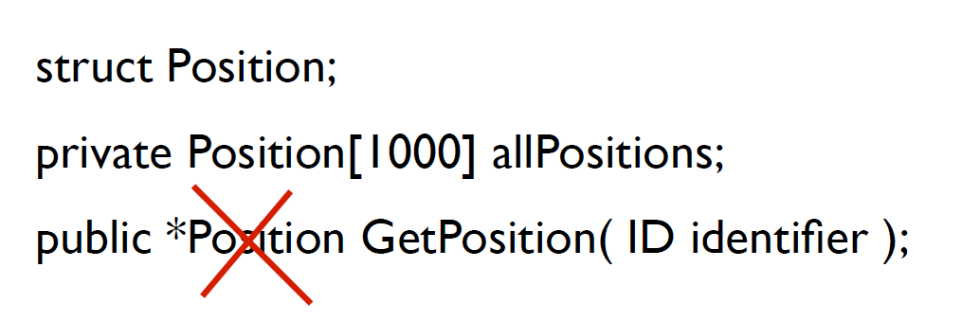

Workarounds

• C# delegate ?

• private -> public ?

• C# Enumerable ?

• C# 7 <--- hope and pray

Unity problem:

Integrate Serialization

(very quick overview;

needs a whole talk in

itself)

Unity Serialization:

ISerializationCallbackReceiver

• Use C# Marshal to convert your game-data

to/from raw byte[]

• Save byte[] as: [SerializeField] private byte[]

• Unity calls incorrectly in 10% of cases

• => monitor + fix on case-by-case basis

• In some edge-cases, Unity doesn’t serialize

• DEAL WITH IT. (i.e. “not-solved-yet”)

Summary...

1. Performance

improves on Unity

With 100,000 GameObjects ... 10-30x faster

2. Replacement for

Inspector works/usable

But nothing special (yet)

3. C# code is pretty

clean, simple to write

Could run MUCH faster if/when C# v7 is added to Unity

EASIER to write if/when C# v7 is added to Unity

4. Many kludges, hacky

source code

But ... IT WORKS!

(proves the concept fairly well)

Next steps...

Future features

• Re-implement prefabs BUT PROPERLY!

• Drag/drop “prefab editor”

• Visual scripting

• Maybe debugging only; Maybe coding too

• Database-backed entity store

• SQL FTW (...maybe)

Features (cont’d)

• AWESOME FUNKTASTIC VISUALIZR!

• (not entirely sure how this’ll look yet)

• Very-High-speed version

• Complex mem-management algorithms

• Auto-integrate with MonoBehaviour

• Control Unity’s Renderer; Physics; etc

Towards the

Asset Store...

• Start using it in my own (hobby) games

• Early-access via Kickstarter, Patreon, or

similar

• Work towards: Production build (good

enough for shipping commercial games)

@t_machine_org

[adam.m.s.martin@gmail.com](mailto:adam.m.s.martin@gmail.com)

<http://aliqua.org>



***(temporary holding page for***

***following the project. Average of***

***1-2 emails per month)***